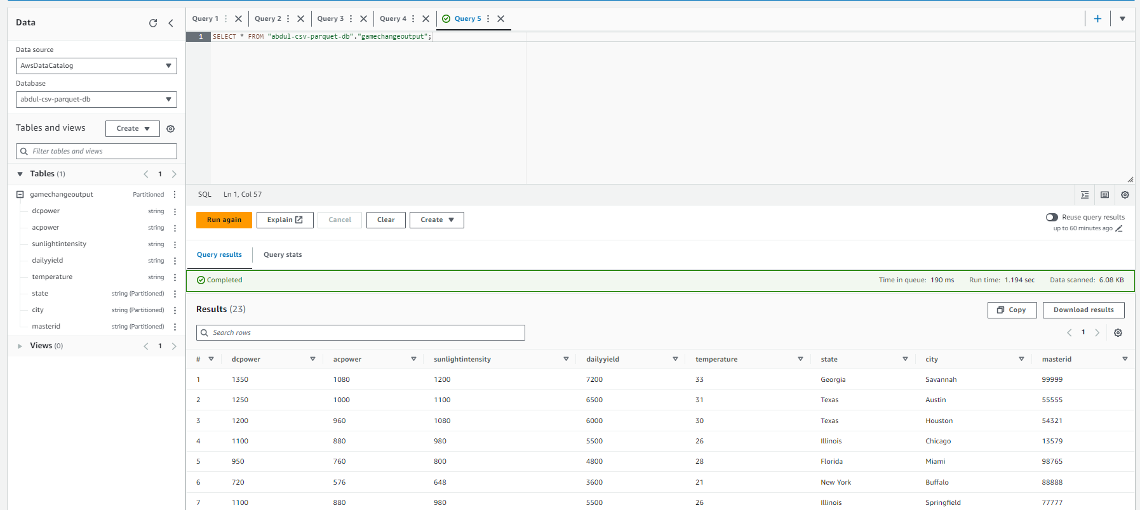**Athena Query Response from Boto3**

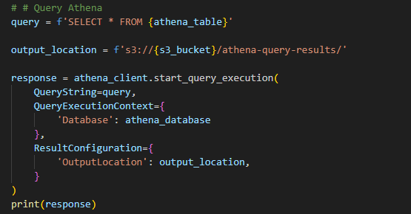

**StartQueryExecutionResponse:**

{

'QueryExecutionId': '03fc0bae-6924-4aed-a6eb-fe1d8085b924',

'ResponseMetadata': {

'RequestId': '395eaa2d-77d0-4cbb-b702-cb2a359fbcb1',

'HTTPStatusCode': 200,

'HTTPHeaders': {

'date': 'Mon, 04 Sep 2023 10:28:06 GMT',

'content-type': 'application/x-amz-json-1.1',

'content-length': '59',

'connection': 'keep-alive',

'x-amzn-requestid': '395eaa2d-77d0-4cbb-b702-cb2a359fbcb1'

},

'RetryAttempts': 0

}

}



**GetQueryResultResponse:**

{

'RESULTS': {

'UpdateCount': 0,

'ResultSet': {

'Rows': [

{

'Data': [

{'VarCharValue': 'dcpower'},

{'VarCharValue': 'acpower'},

{'VarCharValue': 'sunlightintensity'},

{'VarCharValue': 'dailyyield'},

{'VarCharValue': 'temperature'},

{'VarCharValue': 'state'},

{'VarCharValue': 'city'},

{'VarCharValue': 'masterid'}

]

},

{

'Data': [

{'VarCharValue': '850'},

{'VarCharValue': '680'},

{'VarCharValue': '760'},

{'VarCharValue': '4200'},

{'VarCharValue': '21'},

{'VarCharValue': 'Washington'},

{'VarCharValue': 'Seattle'},

{'VarCharValue': '98712'}

]

},

{

'Data': [

{'VarCharValue': '800'},

{'VarCharValue': '640'},

{'VarCharValue': '720'},

{'VarCharValue': '4000'},

{'VarCharValue': '22'},

{'VarCharValue': 'California'},

{'VarCharValue': 'Los Angeles'},

{'VarCharValue': '67890'}

]

},

],

'ResultSetMetadata': {

'ColumnInfo': [

{

'CatalogName': 'hive',

'SchemaName': '',

'TableName': '',

'Name': 'dcpower',

'Label': 'dcpower',

'Type': 'varchar',

'Precision': 2147483647,

'Scale': 0,

'Nullable': 'UNKNOWN',

'CaseSensitive': True

},

{

'CatalogName': 'hive',

'SchemaName': '',

'TableName': '',

'Name': 'acpower',

'Label': 'acpower',

'Type': 'varchar',

'Precision': 2147483647,

'Scale': 0,

'Nullable': 'UNKNOWN',

'CaseSensitive': True

},

# ... (continue with other column info)

]

}

},

'ResponseMetadata': {

'RequestId': 'a64853bd-777f-4ae1-8998-a35a3586257e',

'HTTPStatusCode': 200,

'HTTPHeaders': {

'date': 'Mon, 04 Sep 2023 10:28:08 GMT',

'content-type': 'application/x-amz-json-1.1',

'content-length': '9832',

'connection': 'keep-alive',

'x-amzn-requestid': 'a64853bd-777f-4ae1-8998-a35a3586257e'

},

'RetryAttempts': 0

}

}

}